**AUTOMATIC MUSIC GENERATION**

A Project Report

submitted in partial fulfillment of the requirements

of

……………. Track Name ………….

by

**[V.GANAPATHI](mailto:V.GANAPATHI-ganapathiv360@gmail.com)**

**[ganapathiv360@gmail.com](mailto:V.GANAPATHI-ganapathiv360@gmail.com)**

**D59FFDCEF9EFCC396FD453008D2797D4(au812921114004)**

**812921114004**

Under the Guidance of

**P.Raja, Master Trainer**

**ACKNOWLEDGEMENT**

We would like to take this opportunity to express our deep sense of gratitude to all individuals who helped us directly or indirectly during this thesis work.

Firstly, we would like to thank my supervisor, P.Raja And R.Vijayan for being a great mentor and the best adviser I could ever have. His advice, encouragement and the critics are a source of innovative ideas, inspiration and causes behind the successful completion of this project. The confidence shown in me by him was the biggest source of inspiration for me. It has been a privilege working with him for the last one year. He always helped me during my project and many other aspects related to the program. His talks and lessons not only help in project work and other activities of the program but also make me a good and responsible professional.

#### **ABSTRACT**

Recommendation systems have emerged as a result of the large amount of data available on the Internet. Many firms, such as Amazon and Flipkart for e-commerce, wynk music and ganna.com for music streaming, are now employing recommender systems to their advantage. We provide a framework in this particular situation that can then recommend new melodies to clients based on their preferences. This initiative primarily focuses on providing music recommendations to music fans in order to assist them in listening to tracks that they may enjoy. Clients can use this framework to identify new collections of tunes, making the melodic list available for tuning in. Music is life for music fans, and it has become a larger part of everyone's lives. Music helps us tune in to the cosmos, and the best part about music is that nothing can soothe you like a soothing melody. We chose to do this project because of all the positive aspects of music and the increasing demand for recommender systems on the market. The report comprises a topic description, and a full summary of the work completed thus far. The paper includes thorough explanations of the work completed, including snapshots of implementations, various techniques, and tools used thus far. The project schedule and deliverables are also included in the report. The major goal of music recommendation in this study is to provide strong human-computer interaction and deliver good recommendations to users. It is fluid and can be changed by variables other than the listening history of users or songs.

**TABLE OF CONTENTS**

Abstract

List of Figures

List of Tables

**Chapter 1.**  **Introduction**

1.1 Problem Statement

1.2 Motivation

1.3 Objectives

1.4. Scope of the Project

**Chapter 2.**  **Literature Survey**

**Chapter 3.**  **Proposed Methodology**

**Chapter 4.**  **Implementation and Results**

**Chapter 5. Discussion and Conclusion**

**References**

**LIST OF FIGURES**

|  |  |  |
| --- | --- | --- |
| **Figure Name** | **FIGURE TITLE** | **Page No.** |
|  | Music Recomandation System 1 | **14** |
|  | Music Recommendation System 2 | **18** |
|  | Music Recommendation System 3 | **19** |

**CHAPTER 1**

**Introduction**

The first suggestion system was created in 1979. Elaine Rich defined her Grundy library system [1] as follows: it is used to offer books to users after a brief interview in which the user is requested to fill in his first and last name, and then Grundy asks them to define themselves in a few key terms in order to discover their preferences and classify them as a "stereotype." Grundy provides an initial suggestion by providing a summary of the book after the data has been recorded. If the user is unhappy with the option, Grundy asks questions to figure out which part of the book it made a mistake on and then proposes a fresh one.

Recommendation systems, which first appeared in the 1990s, have advanced significantly in recent years, particularly with the introduction of Machine Learning and networks. On the one hand, the expanding use of today's digital world, which is characterized by a wealth of data, has enabled us to collect massive user databases. On the other hand, when computing power increased, it became possible to handle these data, particularly using Machine Learning, when human skills were no longer capable of conducting a thorough examination of such a large amount of data.

Unlike search engines, which get queries with specific information about what the user wants, a recommendation system does not receive a direct request from the user, but instead must provide them fresh options based on their past behaviors. E-commerce sites that want to sell as many commodities or services as possible to customers (travel, books, etc.) must swiftly recommend appropriate commodities. The purpose of services that provide streaming music and movies is to keep people on their platform for as long as possible. The recurring theme is that appropriate recommendations are required. Recent advancements in this industry have been significant, and these tips are advantageous to both businesses looking to maximize earnings and customers who are no longer overwhelmed by the quantity of options available. Making decisions is therefore made simple, and a good tip saves a lot of time.

The Recommender System is a software application and algorithm that provides suggestions for items that a user is most interested in. Recommendations are used in a variety of real-world situations, such as deciding what products to buy, listening to music, or reading the latest news. On the other side, there has been a shift in recorded commodity music, particularly after Apple acquired Beats Music in 2014 8. The music 7 industry's economic model has recently shifted from commodity sales to subscriptions and streaming. In comparison to prior eras, the availability of digital music is now abundant due to the new business model in the music industry. As a result, the importance of a music recommender system for music suppliers cannot be overstated. It is foreseeing.Collaborative filtering makes suggestions based on the collaborative power of the available evaluation by users.

It is assumed that if people rate music things similarly or behave similarly, they would rate other music items similarly as well. The sparse evaluation matrix is the major issue in collaborative filtering methods since most users only see a tiny portion of all music libraries, hence most assessments are not decided. Content-based filtering, on the other hand, makes suggestions based on the characteristics of the music pieces.

We will see if we can get better recommendations by using real-time data, such as a user's heart rate and the time of day, when making recommendations in this project. The recommendations will be made by a system that employs several machine learning techniques and is accessible via a mobile application.

The system uses a smart watch to recognise the user’s heart rate in order to give recommendations of songs according to what kind of music is usually associated with that heart rate and time of day for that specific user.

**Problem Statement :**

With commercial music streaming service which can be accessed from mobile devices, the availability of digital music currently is abundant compared to previous era. Sorting out all this digital music is a very time-consuming and causes information fatigue. Therefore, it is very useful to develop a music recommender system that can search in the music libraries automatically and suggest suitable songs to users.

In the long-term, the goal is not only to recommend existing songs but also to generate songs adapted to the musical taste of the user. During this master thesis I focused on the recommendation part while exchanging with a colleague in charge of the 14 generation part. The music which selected by the user is used as the basis music for recommendations. The features of basis music are extraction vector is obtained from the best genre prediction model in previous step. Next, the values of cosine similarity are sorted from the largest to the smallest value. The future of the project will consisting gathering these two parts in order to have a fully functional recommendation system.

Because real-time data changes rapidly, an algorithm based on it must be efficient. We want advice that are relevant to the current situation rather than prior situations. Many researchers are presently focusing on machine learning approaches such as neural networks, and they are also becoming more prominent in the field of recommender systems. In terms of results, the major goal was to establish a framework for consumers to use in order to assist them find the ideal tunes for them. This project seeks to discover the correlation and similarity between different songs, and then construct a recommendation system framework that suggests new music for your Spotify playlist based on that information.

They can not only manage the ever-increasing amount of data, but they also increase in quality in proportion to the amount of data evaluated, thanks to the learning algorithms. Indeed, during years, in order to choose music, restaurants, movies, etc.. We have been asking our friends, family, and colleagues to recommend something they liked. And it is this mechanism that is attempted to be reproduced here. Netflix was a pioneer of this method (based on stars given by other users) but it is now widely used, including for Spotify’s Discover Weekly.

Machine learning has become significantly more viable than it has been traditionally as the amount of data has expanded and the processing capacity of computers has improved. The algorithms are made to look for patterns

Because our music choices and our present emotional state are so closely linked, realtime data sources are extremely important for music suggestions. Certain songs or styles of music can affect our mood in various ways, and our musical choices are frequently linked to our mood.

Music selections are also linked to the listener's current activities. Even if we have a certain musical taste, our tastes will shift depending on what we are doing. When a person is working out at the gym, for example, they will likely listen to different tunes than when they are attempting to go asleep at night.

**Motivation:**

The aim of this thesis is to explore the different recommendation approaches, the available datasets, the ways to take into account the user’s preferences and the machine learning methods in order to build a suitable recommendation system. The music which selected by the user is used as the basis music for recommendations. The features of basis music are extraction vector is obtained from the best genre prediction model in previous step.

Next, the values of cosine similarity are sorted from the largest to the smallest value. One important part was only dedicated to determine how to evaluate this recommendation system. This project will be introduced to the members of the company and will take the form of an application.

The user will be asked to upload a music and the application will recommend some music to be listened to afterwards. Collaborative filtering makes suggestions based on the collaborative power of the available evaluation by users.

**Objective:**

The goal of this project was to learn about machine learning and its fundamental concepts, as well as numerous data mining approaches and algorithms. Another goal was to become familiar with a variety of machine learning algorithms and how to use them. Learning algorithms alone does not make you an engineer; the true challenge is determining which method is best for a certain project.

In terms of results, the major goal was to establish a framework for consumers to use in order to assist them find the ideal tunes for them. This project seeks to discover the correlation and similarity between different songs, and then construct a recommendation system framework that suggests new music for your Spotify playlist based on that information.

Long-term, the objective is to not just propose current songs, but also to create songs according to the user's musical preferences. Throughout my master's thesis, I concentrated on the recommendation section while corresponding with a colleague who was in charge of the generating section. The project's future will consist of bringing these two components together to create a fully working recommendation system.

Indeed, during years, in order to choose music, restaurants, movies, etc.. We have been asking our friends, family, and colleagues to recommend something they liked. And it is this mechanism that is attempted to be reproduced here. Netflix was a pioneer of this method (based on stars given by other users) but it is now widely used, including for Spotify’s Discover Weekly. Collaborative filtering makes suggestions based on the collaborative power of the available evaluation by users.

The objective is to recommend the user the types of songs that he would like by comparing his taste i.e., his playlist of music with the songs available in the dataset. By using music recommender system, the music provider can predict and then offer the appropriate songs to their users based on the characteristics of the music that has been heard previously.

Major section was devoted to determining how to assess this recommendation system. This project will be presented to the company's employees in the form of an application. The user will be requested to submit a song, and the program will then offer several songs to listen to.

The idea is not just to recommend current songs but also to produce songs based on the user's musical preferences. During this master's thesis, I concentrated on the suggestion portion while corresponding with a colleague in charge of the generating portion. The project's future will consist of combining these two components to create a fully working recommendation system.

Only one significant section was devoted to determining how to assess this suggestion system. This project will be presented to the company's employees in the form of an application. The user will be invited to upload music, following which the program will suggest some songs to listen to.

The recommendation systems that really emerged in the 1990s have developed strongly in recent years, especially with the introduction of Machine Learning and networks. Indeed, on the one hand, the growing use of the current digital environment, characterized by an overabundance of information has allowed us to obtain large user databases. On the other hand, the increase in computing power made it possible to process these data especially thanks to Machine Learning when human capacities were no longer able to carry out an exhaustive analysis of so much information.

**Scope of the project:**

The recommender system is done by calculating cosine similarity of extraction features (equation 1) from one music to another music. The extraction features are in vector form; thus, it is possible to calculate their distance. First, we chose one music for each genre as the basis for the recommender system. Next the prediction of the basis music genre is calculated based on neural networks. The feature vectors that produce before the classification layer are used as a basis for recommendations. After the basis music features are obtained, cosine similarity calculations are performed on other music features.

The study of the content of the items considered for suggestion is content-based recommendation. This method attempts to deduce the user's tastes in order to suggest goods that are similar in content to those they have previously enjoyed. This approach does not require listener input; it is only based on sound similarity, which is calculated using information taken from previously heard songs.

The commonalities between the components are used in this strategy. It is a question of extracting characteristics that best characterize the music in order to assess similarities. The Machine Learning algorithms then suggest the item that is most similar to what the consumer already loves.

As a result, item profiles based on characteristics derived from things are required. Furthermore, this strategy necessitates the creation of user profiles based on their preferences as well as their platform history.

In the numerator, the calculation is done by calculating dot product of both vectors and in the denominator, the calculation is done by calculating the vector lengths. The obtained value of cosine similarity is between -1 to 1. By sorting the values from the largest to the smallest, the recommendations can be made by choosing several music with the largest cosine similarity. In this research, the number of recommendations is set to be five music. In our experiments, the recommender system uses two methods. The first method only uses the value of cosine similarity, while the second method uses both the value of cosine similarity and information of music genre.

The music which selected by the user is used as the basis music for recommendations. The features of basis music are extraction vector is obtained from the best genre prediction model in previous step. Next, the values of cosine similarity are sorted from the largest to the smallest value. Finally, the first five music with the greatest value is used as recommendations.

**CHAPTER 2**

**Literature Survey**

We were awestruck with Spotify’s recommendation engine. We always wondered how Spotify manages to recommend that perfect song, playlist or even that ‘daily mix’ . We now have more technology than ever before to ensure that if you’re the smallest, strangest musician in the world, doing something that only 20 people in the world will dig, we can now find those 20 people and connect the dots between 20 the artist and listeners. This has been the motivation for this project to use various machine learning techniques and to develop a music recommendation engine similar to that of Spotify, which takes music listening experience to another level. Music Recommendation Systems.

Recommender systems help consumers deal with the problem of information overload by providing them with individualised, unique content and service suggestions. Various methods for developing recommendation systems have recently been created, including collaborative filtering, content-based filtering, and hybrid filtering. The collaborative filtering approach is the most developed and widely used. Collaborative filtering suggests things by locating other users who have similar tastes to the current user and using their recommendations. Collaborative recommender systems have been used in a variety of settings. problems – new items and new users. The first problem refers to the new items that are meant to be recommended, but the information that is associated with them,.

The common characteristics in these systems are constant when using users’ preferences compared with users’ context (location, mood, weather, etc.). For instance, in the library when people are sitting there maybe they need quiet and melodious music to listen according to the environment where they are in. Last.fm, All music, Spotify, Pandora and Shazam are commercial music recommendation systems which are considered to be excellent systems by focusing on the music already played in order to help the users to find more music. Users are able to connect to a web-based music streaming service to access the recommendations. All the tracks that are played on this stream are recommended.

It is Based on songs or artists which users either upload from your iTunes playlists or add as favourites on the site where users start managing their library of music with tags and keep tracking of the music the friends who listening to and getting multiple recommendations per song played. Additionally, this app filters recommendations by decade, genre, and popularity, as well as builds fabulous playlists (Song et al., 2012).t has been found that CF generally gives better recommendations than CB. However, this is only true if there is usage data available, such as the ratings given to previous tracks. If this is not the case, then it will not prove accurate results and, consequently, suffer from the Cold-Start problem, which includes two categories of problems – new items and new users. The first problem refers to the new items that are meant to be recommended, but the information that is associated with them,.

**Methodologies:**

Meanwhile, many researchers have used social media (Twitter & Facebook) to identify user’s mood (tension, depression, anger, vigor, fatigue, confusion) and also identify user’s personality (openness, conscientiousness, extraversion, 21 agreeableness, neuroticism) where these are very important factors which influence on user’s music taste (Wang et al., 2014; Roberts et al., 2012; Pandarachalil et al., 2015; Ross et al., 2009; Bachrach et al., 2012; Back et al., 2010) and also contextual features (location & event) can lead to different emotional effects due to objective features of the situation.

Music lyrics are also considered to be one of emotional presentation because they include some kinds of implicit thinking, thus we can fully understand emotions and their associated thinking in each song (Nunes and Jannach, 2017; Tintarev and Masthoff, 2008). Cano et al. (2017) mentioned that there is a strong relation between the user mood and listening to the music. The people may want to listen to music which has the same mood of them when they are in specific mood and in contrast the people want to listen to different kind of music which encourage them to enhance their mood and this thing depend on the psychological studies and therefore, the author produced a contextual mood-based music recommender system which is able to regulate the driver’s mood and also try to put the driver in a positive mood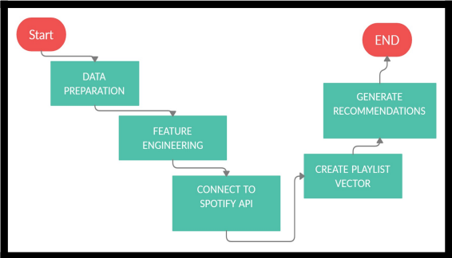.

**Limitation:**

1. only genre metadata was provided

2. Since, the dataset consists of only audio features and no data related to the user's listening history , therefore we cannot perform collaborative filtering techniques.

3. kaggle dataset doesn’t consist of all of the songs in my playlist .

This dataset then went through different data mining techniques to make it suitable for further analysis .

**CHAPTER 3**

**Proposed Methodology**

**Requirements :**

**Functional Requirements**:

The project's functional requirement definition is divided into three categories: user needs, security requirements, and device requirements, each of which is discussed in depth below:

Requirement of the user: To explore the identification for the music suggestion, the user must have an account on the framework and have listened to at least one song.

The project's functional requirement definition is divided into three categories: user needs, security requirements, and device requirements, each of which is discussed in depth below: Requirement of the user: To explore the identification for the music suggestion, the user must have an account on the framework and have listened to at least one song.

The project's functional requirement definition is divided into three categories: user needs, security requirements, and device requirements, each of which is discussed in depth below:

Requirement of the user: To explore the identification for the music suggestion, the user must have an account on the framework and have listened to at least one song.

The project's functional requirement definition is divided into three categories: user needs, security requirements, and device requirements, each of which is discussed in depth below:

Requirement of the user: To explore the identification for the music suggestion, the user must have an account on the framework and have listened to at least one song.

The project's functional requirement definition is divided into three categories: user needs, security requirements, and device requirements, each of which is discussed in depth below:

Requirement of the user: To explore the identification for the music suggestion, the user must have an account on the framework and have listened to at least one song.

**Non-Functional Requirements:**

i)Performance: The framework will produce results that are quick, precise, and trustworthy

ii)Capacity and Scalability: The framework will be able to store identification that has been registered in the database.

iii)Availability: The framework will be available to clients anytime an Internet connection is available.

iv Recovery: In the event of a server failure or inaccessibility, the framework should be able to recover and store any data loss or excess

v) Flexibility and Portability: The system will be accessible at any time and from any location

i. Performance: The framework will produce results that are quick, precise, and trustworthy.

ii. Capacity and Scalability: The framework will be able to store identification that has been registered in the database.

iii. Availability: The framework will be available to clients anytime an Internet connection is available.

iv. Recovery: In the event of a server failure or inaccessibility, the framework should be able to recover and store any data loss or excess.

v. Flexibility and Portability: The system will be accessible at any time and from any location.

**Data Flow Diagram:**

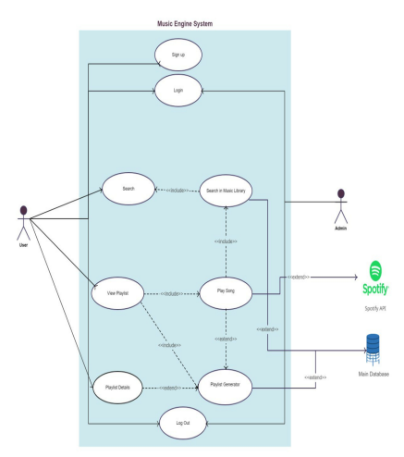

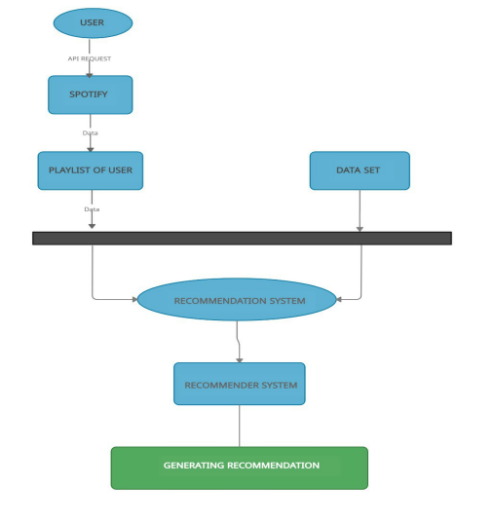

**CHAPTER 4**

**Implementation And Result**

**Discussion on the Results Achieved :**

This assignment provided us with a fantastic learning opportunity. We've studied data mining and data cleansing.The music supplier can forecast and then give acceptable songs to its consumers using a music recommender system based on the qualities of previously heard music. for each song listened to by the user, the average vector of audio and metadata attributes Find the n-closest data points in the dataset (excluding points from the user's listening history) to this average vector. Take these n points and come up with some tunes to go with them.

A research on the limits of an interactive music recommendation service based on artificial audio similarity calculation was provided. A number of computer experiments, as well as a review of real download data, reveal that a large chunk of the audio collection is only never or never suggested. A number of computer experiments are used to investigate this issue in depth, including the investigation of various audio similarity functions and comparisons with real download data. Our music recommendation service uses Gaussian mixtures as statistical models to determine timbre similarity. This is the de facto standard method for computing audiosimilarity, and it is recognised to produce high-quality results.

A machine learning model's first goal is to eliminate all problem-causing objects from the dataset. Data cleansing and exploration were quite beneficial in getting the dataset algorithm ready. We learned how to design a machine learning model, train it, and then test it.

• The songs which scored highest have been recommended in the result given below.

• Smaller the angle, the higher the song score.

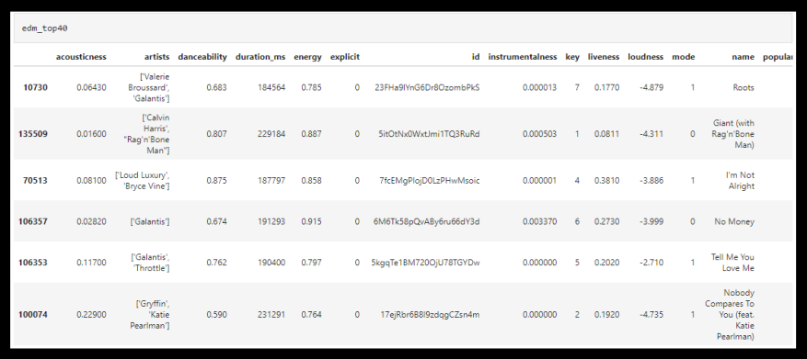

**CHAPTER 5**

**Discussion and Conclusion**

**Git Hub Link of the Project:**

**Limitations:**

This project due to the nature of the dataset fails to provide accurate recommendations as the dataset does not consist of all of the songs in the playlist.This is noteworthy that a dataset can be built and versioned entirely from one data source for user convenience and technical simplicity. That is, data sources in a dataset cannot presently be mixed and matched (for example, a dataset built from a GitHub repository cannot include files uploaded from your local system). You can build numerous datasets and add them both to a Notebook if you want to leverage multiple distinct data sources in it.

Songs that are identical to a large number of other songs and hence appear unnecessarily frequently in recommendation lists prevent a big section of the audio library from being recommended at all. A number of computer experiments are used to investigate this issue in depth, including the investigation of various audio similarity functions and comparisons with real download data.

For user convenience and technological simplicity, a dataset can be generated and versioned fully from a single data source. That is, data sources in a dataset cannot be mixed and matched at this time 56 (for example, a dataset built from a GitHub repository cannot include files uploaded from your local system).

The programme will allow users to listen to recommended tracks based on the music or extract. A dataset can be built and versioned entirely from one data source for user experience and technical simplicity.The music supplier can forecast and then give acceptable songs to its consumers using a music recommender system based on the qualities of previously heard music. for each song listened to by the user, the average vector of audio and metadata attributes Find the n-closest data points in the dataset (excluding points from the user's listening history) to this average vector. Take these n points and come up with some tunes to go with them. That is, data sources in a dataset cannot presently be mixed and matched (for example, a dataset built from a GitHub repository cannot also include files uploaded from your local workstation). You may build numerous datasets and add them both to a Notebook if you want to leverage different data sources in it.

**Future Work:**

The range of characteristics covered by the recommender system is extensive. In today's generation of e-services and commerce, it is growing and evolving. However, there is a requirement to create and optimise the working and output of the recommender system at the same time. For user convenience and technological simplicity, a dataset can be generated and versioned fully from a single data source. That is, data sources in a dataset cannot be mixed and matched at this time (for example, a dataset built from a GitHub repository cannot include files uploaded from your local system).

The programme will allow users to listen to recommended tracks based on the music or extract.

Several service providers provide consumers with a shopping list. However, this is insufficient since consumers have varying preferences and decisions that are influenced by a variety of circumstances and restrictions. It may also be impossible to propose specific things to individual users in many circumstances. As a result, there is potential for combining several dimensions into music recommender systems in particular.

We were unable to create a model utilising singular value decomposition and support vector machines due to a lack of time. Because popularity-based models are adept at making suggestions, we'll aim to utilise it to forecast the top-N songs for the users who are most popular at any given time.

ndeed, during years, in order to choose music, restaurants, movies, etc.. We have been asking our friends, family, and colleagues to recommend something they liked. And it is this mechanism that is attempted to be reproduced here. Netflix was a pioneer of this method (based on stars given by other users) but it is now widely used, including for Spotify’s Discover Weekly. Collaborative filtering makes suggestions based on the collaborative power of the available evaluation by users.

Customers are less likely to use the majority of the items and services offered by various e commerce sites since they are pricey. As a result, you won't be able to accurately and properly rank an item or collection of things. As a result, typical recommender system strategies are inadequate. This paves the path for more research and development in the form of an efficient recommender system that also considers constraints.we'll aim to utilise it to forecast the top-N songs for the users who are most popular at any given time.

Discover Weekly is a 30-song playlist that includes music that are similar to what the user is listening to. This, like its daily mixes and tailored playlists, is made possible by AI and big data. The system also considers the user's streaming history and playlists, as well as their current music preferences, to improve this suggestion.

Spotify is planning to launch a live audio streaming function in order to improve its users' 'tailored' experience. Locker Room, a live audio app for creating conversations about music and culture, was recently bought by Spotify.

It will allow users to listen to recommended tracks, there is potential for combining several dimensions into music recommender systems in particular.

**REFERENCES**

1. Aiolli, F. (2012). A preliminary study on a recommender system for the million songs dataset challenge. PREFERENCE LEARNING: PROBLEMS AND APPLICATIONS IN AI
2. Spotify. (2013, March) Spotify Music for everyone. [Online].
3. https://www.spotify.com/us/ [10] (2013, March) Wikipedia. [Online].
4. Peter Knees and Markus Schedl. Music retrieval and recommendation – a tutorial overview. In Proceedings of the 38th Annual International ACM SIGIR Conference on Research and Development in Information Retrieval (SIGIR), Santiago, Chile, August 2015.
5. 5. Peter Knees and Markus Schedl. Music Similarity and Retrieval: An Introduction to Audioand Web-based Strategies. 2016.